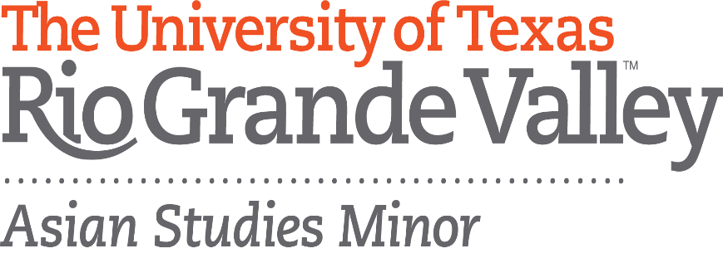

**Asian Spring Festival**

**Wednesday, April 5, 2017**

**11:00am - 2:00pm**

**East Chapel Lawn & Student Union Lobby,**

**UTRGV Edinburg**

Students of Korean Studies and UTRGV Student Associations in partnership with Asian Studies Minor are hosting the 1st **Asian** **Spring** **Festival** at UTRGV on Edinburg campus.

Asian Spring Festival is to explore the new world of Asia right on our campus by participating in exciting cultural activities, traditional games, folk music, dance performances, food tasting and many more.

**Come and Try out:**

* Hena tattooing (presented by Indian Culture Association)
* Animation books & characters and Dango tasting (prepared by Japanese Animation Club)
* Japanese word sling shot games and origami (offered by Japanese Language & Culture Club)
* Hand-paintings, memory game, and paper lanterns (presented by Chinese Language & Culture Association)
* Korean calligraphy, mask printing, traditional musical instruments, and traditional games (hosted by Korean Studies classes)

**Classes of Korean Studies present:**

* Korean Percussion Music (Nongak) at 11:00 and 12:00
* Traditional Fan Dance (Buchaechum) at 11:10 and 11:40
* K-pop Dance at 11:20 and 11:50
* K-pop Song and Guitar at 11:30 and 12:40
* Korean Mask Dance(Talchum) at 12:20 and 1:10
* Research posters in the lobby of Student Union

Please join us in celebrating Asian Spring Festival and the launching of Asian Studies Minor.

Supported by

Office of Global Engagement

Department of Writing & Language Studies

Houston Korean Education Center